

Topic test 2
Name: __________________________________

Chapter 6: Trigonometric functions

• Time allowed: 45 minutes
• CAS calculators may be used.
• Part A: 5 multiple-choice questions (5 marks)
• Part B: 7 short answer questions (42 marks)
• Part C: 3 analysis questions (27 marks)
Part A
5 multiple-choice questions
1 mark each: 5 marks
Circle the correct answer.
1 Find the amplitude and period of the function f(x) = 2 − 5 cos (2px).
A Amplitude 2, period 2π
B Amplitude 5, period π
C Amplitude −5, period 1
D Amplitude −5, period π
E Amplitude 5, period 1

[1 mark]
2 The equation of the graph below is:
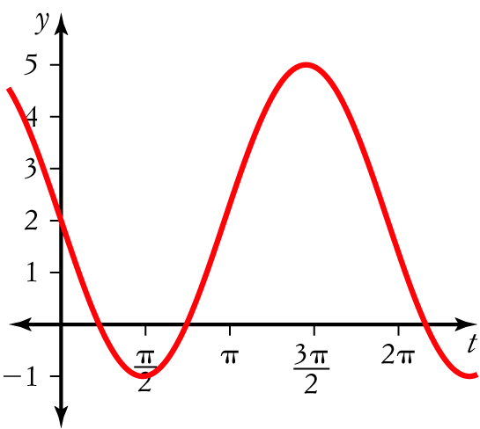
A y = 3 sin (x) + 2
B y = 3 − 2 sin (x)
C y = 2 − 3 sin (x)
D y = 2 + 6 sin (x)
E y = 2 − 6 sin (x)
[1 mark]
3 Which statement is not correct?
A sin2 (x) + cos2 (x) = 1
B tan (x) 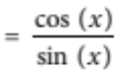
C cos (x − y) = cos (x) cos (y) + sin (x) sin (y)
D cos 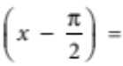 sin (x)
E sin 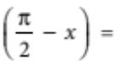 cos (x)

[1 mark]
4 Solve cos (2x) = −1 for 0 ≤ x ≤ 2π.
A x 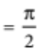,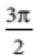
B x 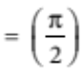
C x = 0, π, 2π
D x 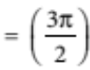
E x = π, 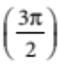

[1 mark]
5 Find the exact value of sin (105°).
A 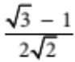
B 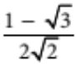
C 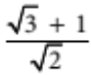
D 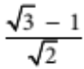
E 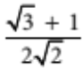

[1 mark]
Part B
7 short answer questions
42 marks
Show your working where appropriate.
1 Find the value of:
a cos (0) ____________________
b tan (2π) ____________________
c sin ____________________
d cos (π) ____________________
e tan (180°) ____________________
[5 marks]
2 For the domain 0 ≤ x ≤ 2π, sketch the graph of:
a y = tan (x)

b y = sin (x) + 3

c y = 1 − 2 cos (x)

d y = 2 cos 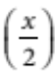

e y = 1 + tan 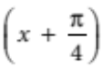

[10 marks]
3 Expand
a tan (2a + b)

b cos (5a − 3b)

c sin (7p − q)

[3 marks]
4 By drawing the graphs of y = 3 cos (2x) and y = x + 1 on the same set of axes, graphically solve
3 cos (2x) = x + 1. You may use a CAS calculator.

[4 marks]
5 For 0° ≤ x ≤ 360° solve
a tan (x) = 1

b sin (x) 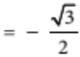

c tan (2x) 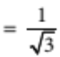

[11 marks]
6 Solve 2 cos2 (θ) − 1 = 0 for 0 ≤ θ ≤ 2π.

[5 marks]
7 a State the amplitude and period of the function below.

b Find an equation that models this function.
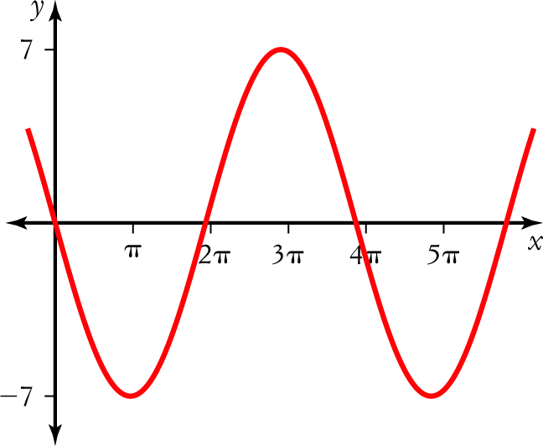

[4 marks]

Part C
3 analysis questions
27 marks
Show your working where appro riate.
1 Below is a table showing the heights of the tides over a three day period.
Day | Friday |  |  |  | Saturday |  |  |  | Sunday
Time | 6.20 a.m. | 11.55 a.m. | 6.15 p.m. | 11.48 p.m. | 6.20 a.m. | 11.55 a.m. | 6.15 p.m. | 11.48 p.m. | 6.20 a.m. | 11.55 a.m. | 6.15 p.m. | 11.48 p.m.
Tide (m) | 3.2 | 1.1 | 3.4 | 1.3 | 3.2 | 1.2 | 3.5 | 1.1 | 3.4 | 1.2 | 3.5 | 1.3

a Draw a graph showing the tides.


b Find the period and amplitude.

c Estimate the height of the tide at around 8 a.m. on Friday.

[6 marks]
2 In an unusual meteorological investigation, the temperature, T °C, in a town in central Queensland was found to fluctuate approximately according to the rule
T = 25 + 6 sin (0.1t), where t is the number of hours after 10:00 a.m.
a Sketch a graph of the temperature fluctuations for a sufficient number of hours such that you are able to determine the maximum and minimum temperatures for that day and the next night.

b Use the graph to determine the maximum and minimum temperatures.

c When did they occur?

d At what time was the temperature:
i 27°C? ____________________
ii 20°C? ____________________
e Why was this unusual?

[9 marks]
3 a Show how cos (2x) can be expressed in terms of cos (x).

b Show how sin (2x) can be expressed in terms of sin (x) and cos (x).

c Hence show how cos (3x) can be expressed in terms of cos (x).

[12 marks]
Total marks: 74
Answers
Part A [1 mark each]
1 Amplitude = 5
Period 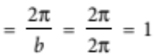
E [1 mark]
2 Amplitude = 3
Period = 2π
y = sin (x) is reflected in the x-axis and translated up 2 units.
y = 2 − 3 sin (x)
C [1 mark]
3 tan (x) 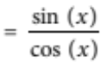
B [1 mark]
4 y = cos (2x) has period 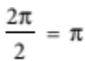
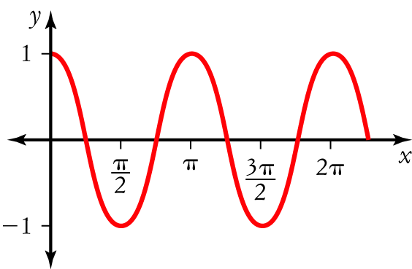
From the graph x 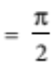,
A [1 mark]
5 sin (105°) = sin (60° + 45°)
= sin (60°) cos (45°) + cos (60°) sin (45°)
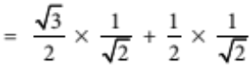
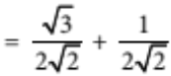
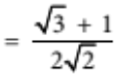
E [1 mark]
Part B
1 a cos (0) = 1 [1 mark]
b tan (2π) = 0 [1 mark]
c sin = −1 [1 mark]
d cos (π) = −1 [1 mark]
e tan (180°) = 0 [1 mark]
2 a Period = π [1 mark]
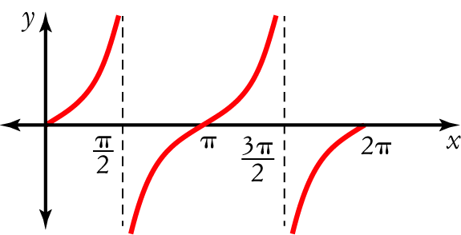
[1 mark]
b y = sin (x) translated 3 units up. [1 mark]
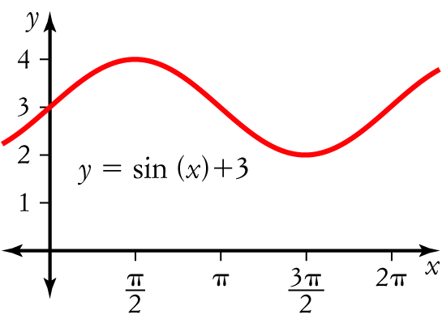
[1 mark]
c Amplitude = 2, translated 1 unit up, reflected in the x-axis. [1 mark]
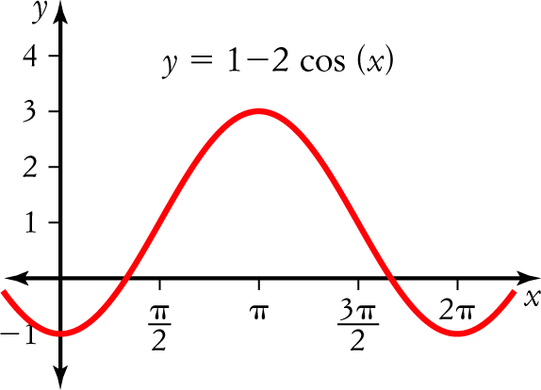
[1 mark]
d Period = 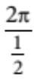 = 4π, amplitude = 2 [1 mark]
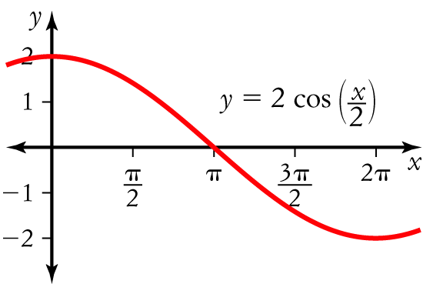
[1 mark]
e The graph y = tan (x) is translated units to the left and up 1 unit. [1 mark]
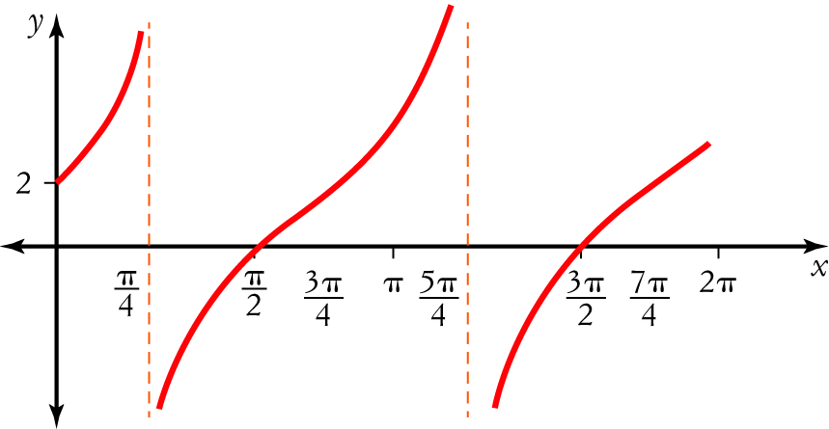
[1 mark]
3 a tan (2a + b) 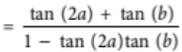 [1 mark]
b cos (5a − 3b) = cos (5a) cos (3b) + sin (5a) sin (3b) [1 mark]
c sin (7p − q) = sin (7p) cos (q) − cos (7p) sin (q) [1 mark]
4 On the CAS calculator or freehand, draw both graphs.
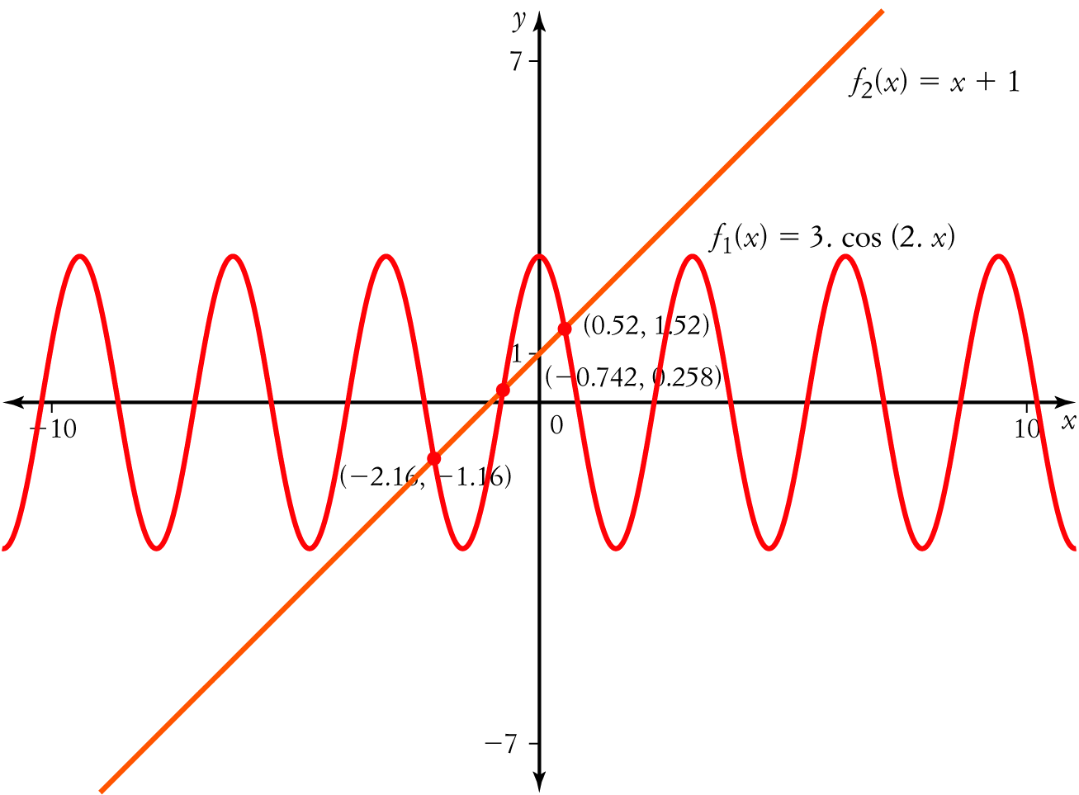
[3 marks]
x = −2.16, −0.742, 0.52 [1 mark]
5 a From the triangle, tan (45°) = 1 [1 mark]
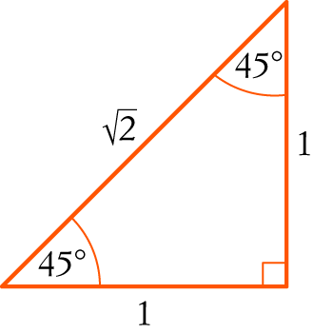
x = 45°, 180° + 45° (tan is positive in the 1st and 3rd quadrants) [1 mark]
= 45°, 225° [1 mark]
b From the triangle, sin (60°) = 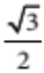 [1 mark]
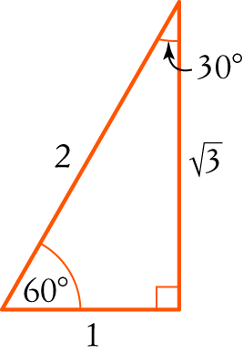
x = 180° + 60°, 360° − 60° (sin is negative in the 3rd and 4th quadrants) [1 mark]
= 240°, 300° [1 mark]
c From the triangle, tan (30°) = 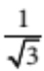 [1 mark]
0° ≤ x ≤ 360°
0° ≤ 2x ≤ 720° [1 mark]
2x = 30°, 180° + 30°, 360° + 30°, 360° + 180° + 30° (tan is positive in the 1st and
3rd quadrants) [1 mark]
= 30°, 210°, 390°, 570° [1 mark]
x = 15°, 105°, 195°, 285° [1 mark]
6 2 cos2 (θ) = 1
cos2 (θ) = [1 mark]
cos (θ) =  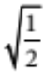
= 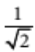
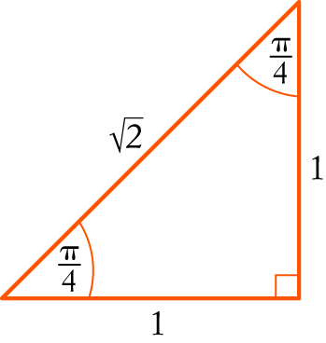
[1 mark]
From the triangle, cos 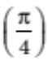 =
θ = , π − , π + , 2π − (all quadrants) [2 marks]
= ,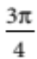 , 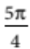 , 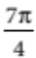 [1 mark]
7 a Amplitude = 7 [1 mark]
Period = 4p [1 mark]
b 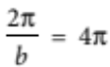
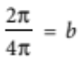
= b [1 mark]
Substitute into y = −a sin (bx) (reflected in the x-axis).
y = −7 sin [1 mark]
Part C
1 a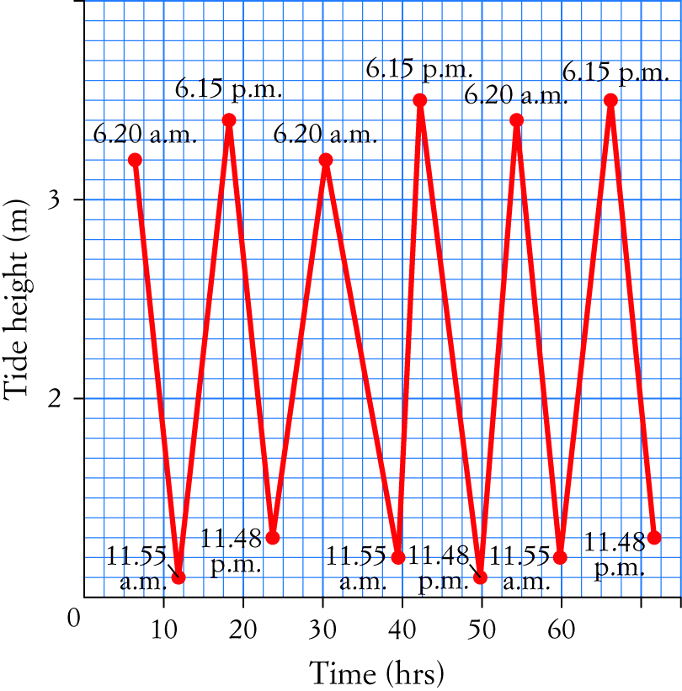
[3 marks]
b Period 24 hours, amplitude 1.25. [2 mark]
c About 2.5 m. [1 mark]
2 a Period 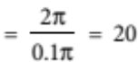, amplitude = 6, the graph is translated 25 units upwards. [1 mark]
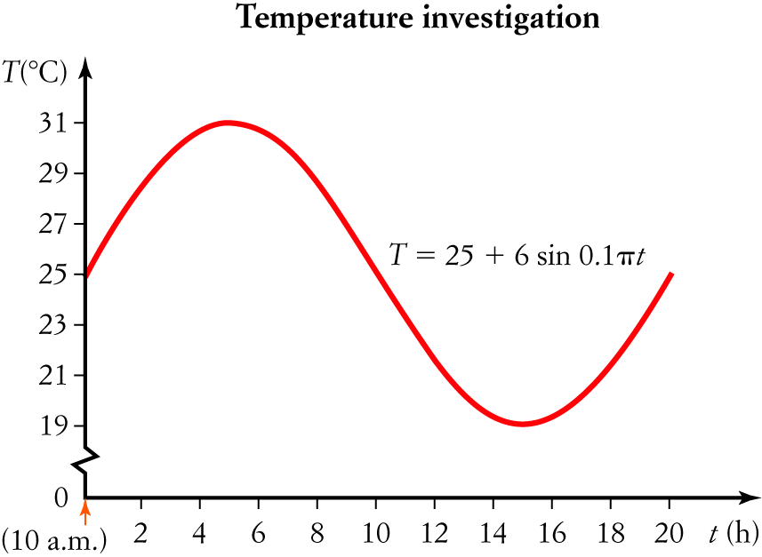
[2 marks]
b From the graph, the highest was 31° C and the lowest was 19° C. [2 marks]
c The highest occurred at 3 p.m., the lowest occurred at 1 a.m. [2 marks]
d i 11.05 a.m., 6.55 p.m., … [1 mark]
ii 11.08 p.m., 2.52 a.m., … [1 mark]
e This is unusual because the period is not 24 hours. [1 mark]
3 a cos (2x) = cos (x + x)
= cos (x) cos (x) − sin (x) sin (x) [1 mark]
= cos2 (x) − sin2(x) [1 mark]
= cos2 (x) − [1 − cos2(x)] [1 mark]
= cos2 (x) − 1 + cos2(x)
= 2 cos2 (x) − 1 [1 mark]
b sin (2x) = sin (x + x)
= sin (x) cos (x) + cos (x) sin (x) [1 mark]
= 2 sin(x) cos(x) [1 mark]
c cos (3x) = cos(2x + x)
= cos (2x) cos (x) − sin (2x) sin (x) [1 mark]
= [2 cos2 (x) − 1] cos (x) − 2 sin (x) cos (x) sin (x) [1 mark]
= 2 cos3 (x) − cos (x) − 2 sin2 (x) cos (x) [1 mark]
= 2 cos3 (x) − cos (x) − 2[1 − cos2 (x)] cos (x) [1 mark]
= 2 cos3 (x) − cos (x) − 2 cos (x) + 2 cos3 (x) [1 mark]
= 4 cos3 (x) − 3 cos (x) [1 mark]

